**Accessing Canvas as a Parent**

* Canvas is our new Learning Management System.  Teachers will post announcements, meetings, notes, assignments, quizzes, tests, etc all in Canvas.  As a parent, you can have a Canvas account that is paired with your student's account.  This provides you the ability to see everything assigned to your student, see what is due and when it is due, know if your student has turned assignements in, and view feedback on assignments from the teacher.  Follow the directions below to get started.

1.  Create you account here <https://rcboe.instructure.com/login/canvas>

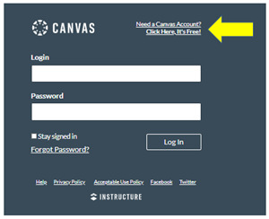

 2.  Click on "Parents Sign Up Here"

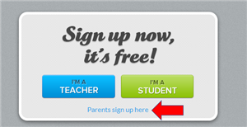

3.  Fill in your username, email, and password.

4.  In a new tab, go to Launchpad and click on your students Canvas app.  <https://launchpad.classlink.com/rcboe>

5.  Click on account in the top left hand corner.

6.  Click on settings.

7.  On the right side of the screen, click on "Pair with Observer."

**Scroll Down for more information**

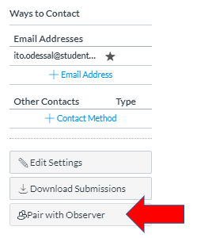

8.  Copy the code to your clipboard.

9.  Go back to the tab where you were creating your account and paste the code you copied into the space that reads "Student Pairing Code."

10.  Once logged in, you will see all of your student's courses on the Dashboard.  You may click each course to see the course syllabus, assignments, etc.  You may click on the calendar to view due dates.

**You may also pair multiple students to your account.**

1.  To do this, in your parent account, click on "account" in the top left hand corner.

2.  Click on "Observing."

3.  Follow steps 4-8 to get the pairing code for other students.

**There is also an app you may download to your phone for Canvas Parents.  You will need to be logged into YOUR parent account on the computer.**

1.  Go to the app store on your phone.

2.  Search for Canvas Parent and download the app to your phone.



3. Go to your account on the computer.

4.  Click on account in the top left hand corner.

5.  Click on "QR for Mobile Login."

6.  With the Canvas Parent app opened on your phone, click on QR login and scan the QR code that you see on the computer.

7.  This will log you into your Canvas Parent account on your phone.

Please reach out to your student's teacher if you have any questions!!!